The Effect of Temperature and Ionic Liquid Structure on the Carbon Dioxide Absorption of Hydrophobic Protic Ionic Liquids
Nurin Athirah Mohd Mazlan¹, Madelyn Wen Qian Teoh², Asyraf Hanim Ab Rahim^{1,3}, Gani Purwiandono⁴ and Normawati M. Yunus ^{1,3,}*
¹ Department of Applied Science, Universiti Teknologi PETRONAS, Seri Iskandar 32610, Perak, Malaysia; nurin_21001438@utp.edu.my (N.A.M.M.), asyrafhanim92@gmail.com (A.H.A.R.)
² Nanotechnology and Catalysis Research Centre (NANOCAT), Universiti Malaya 50603, Kuala Lumpur, Malaysia; teohwq2201@gmail.com (M.W.Q.T.)
³ Centre for Research in Ionic Liquid (CORIL), Institute of Sustainable Energy and Resources (ISER), Universiti Teknologi PETRONAS, Seri Iskandar 32610, Perak, Malaysia
⁴ Department of Chemistry, Universitas Islam Indonesia, Sleman 55584, Indonesia; gani_purwiandono@uii.ac.id (G.P.)
* Correspondence: normaw@utp.edu.my

Abstract
This study investigates the effect of temperature and cation structure on the CO₂ absorption performance of newly synthesized hydrophobic protic ionic liquids (HPILs) based on diethylammonium ([DEA][Tf₂N]), triethylammonium ([TEA][Tf₂N]), and bis(2-ethylhexyl)ammonium ([BEHA][Tf₂N]) salts. The HPILs were prepared via a two-step reaction, solvent-free synthesis and characterized by using Nuclear Magnetic Resonance (NMR), Thermogravimetric Analysis (TGA), followed by density and refractive index measurements. CO₂ solubility was evaluated at 298.15, 313.15, and 333.15K under pressures up to 20 bar. Results showed that CO₂ solubility increases with pressure but decreases with temperature, indicating a physical absorption mechanism. Among the studied ILs, [BEHA][Tf₂N] exhibited the highest CO₂ capacity at 298.15K and 20 bar, along with the most negative enthalpy of absorption, attributed to its larger cation size and consequently greater free volume (V_{f}). Besides, [BEHA][Tf₂N] also maintained excellent structural integrity over repeated absorption–desorption cycles. The findings confirm that HPILs, particularly [BEHA][Tf₂N], represent energy-efficient and recyclable alternatives to traditional amine solvents for CO₂ capture applications.
Keywords: ammonium-based protic ionic liquids; free volume; density; refractive index; recyclability.
_________________________________________________________________________________

1.0 Introduction
Carbon dioxide (CO₂) is a major greenhouse gas contributing significantly to global warming and climate change [1,2]. Its continuous increase in the atmosphere, primarily from fossil fuel combustion, has become a critical environmental concern. In the energy sector, natural gas is often regarded as a cleaner alternative to coal and oil due to its lower carbon intensity. However, natural gas typically contains impurities such as CO₂, hydrogen sulfide (H₂S), and water vapor, which reduce its heating value and promote corrosion in pipelines and processing equipment [3–6]. Therefore, the removal of CO₂ is essential to ensure gas quality, process safety, and compliance with environmental standards.
Among the available separation techniques, chemical absorption using aqueous alkanolamines, particularly monoethanolamine (MEA), remains the dominant industrial process because of its high efficiency and reversibility [5–8]. Nevertheless, this method suffers from several drawbacks, including high energy requirements for solvent regeneration, solvent degradation, volatility, and equipment corrosion [9]. Other technologies such as adsorption and membrane separation have been explored, however, they also face challenges related to cost, selectivity, and scalability [10,11].
Therefore, ionic liquids (ILs) have emerged as promising alternatives to conventional solvents owing to their negligible vapor pressure, high thermal stability, and tunable physicochemical properties [7,12–14]. Imidazolium-based and task-specific ionic liquids (TSILs) have demonstrated notable CO₂ absorption capacities [15], but their large-scale application is limited by complex synthesis routes, high production costs, and the use of hazardous reagents [13]. To overcome these issues, protic ionic liquids (PILs) have attracted increasing interest as they can be synthesized via simple acid-base neutralization reactions without organic solvents [16,17]. Although some PILs exhibit comparable CO₂ absorption capacities to conventional ILs, their hydrophilic nature and moderate thermal stability restrict practical application.
Hydrophobic protic ionic liquids (HPILs) have been developed to address these limitations by incorporating non-polar alkyl groups, thereby reducing water uptake, enhancing thermal stability, and improving CO₂ selectivity [18,19]. Despite their promising characteristics, studies on HPILs synthesized from simple amines such as triethylamine (TEA), diethylamine (DEA), and bis(2-ethylhexyl)amine (BEHA) with the bis(trifluoromethylsulfonyl)imide anion ([Tf₂N]⁻) remain limited. Furthermore, the effects of cation structure and temperature on CO₂ solubility in these HPILs are not yet fully understood. Thus, in this study, three novel HPILs with different cation structures were synthesized and characterized. Their thermal properties and CO₂ absorption behavior were evaluated over a pressure range of 1–20 bar and temperatures of 298.15–333.15 K. Recyclability tests were also conducted to assess their potential as sustainable and efficient solvents for CO₂ capture.
2.0 Materials and Methods
2.1 Materials
All chemicals of analytical grade were used without additional purification process for the synthesis of HPILs as well as for CO₂ absorption. The CAS number, source and chemical purity are as follows: diethylamine (109-89-7, Merck, 99%), triethylamine (121-44-8, Merck, 99%), bis(2-ethylhexyl)amine (106-20-7, Aldrich Chemistry, 99%), hydrochloric acid (7647-01-0, Fischer Scientific, 37%) , lithium bis(trifluoromethylsulfonyl)imide (90076-65-6, Sigma Aldrich, 99%), dichloromethane (75-09-2, Merck, 99%).
2.2 Synthesis and Characterization
Diethylamine (DEA), triethylamine (TEA), and bis(2-ethylhexyl)amine (BEHA) were reacted with hydrochloric acid in equimolar ratios under ice-bath conditions to form [DEA][Cl], [TEA][Cl], and [BEHA][Cl]. Each reaction mixture was stirred for 24 h, dried under reduced pressure, and subsequently converted to the corresponding HPILs by anion exchange with lithium bis(trifluoromethylsulfonyl)imide (LiTf₂N) in deionized water. The reaction mixture was stirred for 24 h for [TEA][Tf₂N] and [DEA][Tf₂N], and 48 h for [BEHA][Tf₂N]. The ionic liquid layer was extracted using dichloromethane and dried by rotary evaporation. All HPILs were obtained as liquids, except [DEA][Tf₂N], which remained solid at room temperature.
Structural confirmation was performed using ¹H and ¹³C NMR (Bruker Avance III, 500 MHz). Water content was determined via coulometric Karl Fischer titration (Mettler Toledo V30). Thermal stability was analysed using a PerkinElmer STA 6000 thermogravimetric analyser.
The densities of the liquid HPILs were measured using a 2 mL glass pycnometer between 293.15 and 333.15 K, while the solid-state density was measured at 298.15K using a Micromeritics AccuPyc II gas pycnometer. Refractive indices were determined in triplicate using an ATAGO RX-5000 Alpha digital refractometer within the same temperature range.
2.3 CO₂ Absorption and Recyclability
CO₂ solubility was measured using a pressure-drop method with a stainless-steel equilibrium cell maintained at 298.15, 313.15, and 333.15K over pressures of 1–20 bar. The absorbed moles of CO₂ and Henry’s law constants were calculated from pressure–volume data using the equations provided in Appendix A. The HPIL with the highest CO₂ capacity was tested for recyclability through two absorption–desorption cycles, regenerated at 60°C for 2 h, and re-analysed by FTIR and ¹H NMR to confirm structural stability.
3.0 Results and Discussion
3.1 Structural Confirmation
The ¹H and ¹³C NMR data for each ionic liquid are summarized below, along with the measured water content, confirming that all HPILs were successfully synthesized.
[DEA][Cl]: ¹H NMR (500 MHz, CDCl₃): δ 9.339 [s, 1H, RN⁺H₂], 3.309 [s, 1H, R-NH], 2.979 [q, 4H, N-CH₂], 1.408 [t, 6H, CH₃]. ¹³C NMR (125 MHz, CDCl₃): δ 42.31, 11.17. Water content: 1.579%.
[DEA][Tf₂N]: ¹H NMR (500 MHz, DMSO): δ 8.179 [s, 1H, RN⁺H₂], 2.935 [q, 4H, N-CH₂], 1.160 [t, 6H, CH₃]. ¹³C NMR (125 MHz, DMSO): δ 123.49, 120.93, 118.37, 115.81, 41.54, 11.15. Water content: 0.142%.
[TEA][Cl]: ¹H NMR (500 MHz, CDCl₃): δ 11.535 [s, 1H, RN⁺H], 3.035 [q, 6H, N-CH₂], 2.710 [s, 1H, R-N⁺H], 1.310 [t, 9H, CH₃]. ¹³C NMR (125 MHz, CDCl₃): δ 45.92, 8.63. Water content: 3.319%.
[TEA][Tf₂N]: ¹H NMR (500 MHz, DMSO): δ 8.874 [s, 1H, RN⁺H], 3.095 [q, 6H, N-CH₂], 1.179 [t, 9H, CH₃]. ¹³C NMR (125 MHz, DMSO): δ 123.50, 120.94, 118.38, 115.82, 45.98, 8.74. Water content: 0.476%.
[BEHA][Cl]: ¹H NMR (500 MHz, CDCl₃): δ 2.826 [d, 4H, N-CH₂], 1.874 [m, 2H, -CH], 1.413 [m, 16H, aliphatic CH₂], 0.912 [t, 12H, -CH₃]. 13C NMR (125 MHz, CDCl₃): δ 50.59, 35.57, 30.43, 28.27, 23.71, 22.85, 14.02, 10.17. Water content: 0.735%.
[BEHA][Tf₂N]: ¹H NMR (500 MHz, DMSO): δ 2.796 [d, 4H, α-CH₂], 1.639 [m, 2H, N-CH₂-CH], 1.286 [m, 16H, aliphatic CH₂], 0.844 [m, 12H, CH₃]. ¹³C NMR (125 MHz, DMSO): δ 123.81, 121.25, 118.69, 116.13, 51.86, 36.28, 30.21, 28.31, 23.45, 22.85, 14.35, 10.47. Water content: 0.376%.
3.2 Thermal Properties Analysis
Thermogravimetric analysis showed that all chloride salts decomposed at similar temperatures between 205 and 238°C, indicating comparable stability governed mainly by the chloride anion. The [Tf₂N]⁻-based salts were much more stable, decomposing between 341 and 438°C due to the bulky, charge-delocalized anion that suppresses thermal degradation. Among them, [TEA][Tf₂N] exhibited the highest stability, while [BEHA][Tf₂N] was slightly less stable because its long-branched chains increased free volume and weakened ionic interactions. This trend agrees with earlier studies showing that longer alkyl
3.3 Density and Refractive Index Measurements
The density of ionic liquids is strongly temperature dependent, typically decreasing with increasing temperature due to thermal expansion and reduced intermolecular cohesion. The densities of [TEA][Tf₂N] and [BEHA][Tf₂N] were measured between 293.15 and 333.15K, while [DEA][Tf₂N] remained solid at room temperature. At 298.15K, the densities were 1.44, 1.20, and 1.65 g cm⁻³ for [TEA][Tf₂N], [BEHA][Tf₂N], and [DEA][Tf₂N], respectively, following the order [DEA][Tf₂N] > [TEA][Tf₂N] > [BEHA][Tf₂N]. This trend reflects the influence of cation size and structure on packing efficiency, where the compact [DEA]⁺ forms stronger hydrogen bonds with [Tf₂N]⁻, while the bulky [BEHA]⁺ cation introduces greater free volume. The temperature dependence of [TEA][Tf₂N] and [BEHA][Tf₂N] fitted well to a linear model, yielding thermal expansion coefficients on the order of 10⁻⁴ K⁻¹, consistent with literature values. The calculated molar and molecular volumes increased with cation size, confirming greater free volume and weaker ionic interactions for [BEHA][Tf₂N].
Refractive index measurements for [TEA][Tf₂N] and [BEHA][Tf₂N] over 293.15–333.15K showed a linear decrease with temperature (Figure X), paralleling the density trend. At 298.15K, [BEHA][Tf₂N] exhibited a higher refractive index despite its lower density, attributed to higher molar refraction and ionic polarizability. Calculations based on the Lorentz–Lorenz relation indicated that [BEHA][Tf₂N] has greater molar refraction and free volume than [TEA][Tf₂N], consistent with its bulkier and more polarizable cation. Similar behavior has been reported for ammonium based ionic liquids with longer alkyl chains. The refractive index of [DEA][Tf₂N] was not measured due to its solid state but is expected to be the lowest in the series because of its smaller cation and reduced polarizability.
3.4 CO₂ Solubility and Characterization
The solubility of CO₂ in [DEA][Tf₂N], [TEA][Tf₂N], and [BEHA][Tf₂N] was investigated at 298.15 to 333.15K and pressures up to 20 bar. The CO₂ mole fraction increased linearly with pressure, following Henry’s law, while solubility decreased with increasing temperature due to the exothermic nature of the absorption process. The increase in Henry’s law constants with temperature confirms that higher thermal energy weakens the interaction between CO₂ and the liquid phase, promoting gas release.
HPILs | K_{H} (bar)
HPILs | T = 298.15K | T = 313.15K | T = 333.15K
CO₂ + [DEA][Tf₂N] | 38.70 | 39.29 | 44.09
CO₂ + [TEA][Tf₂N] | 30.12 | 32.81 | 36.33
CO₂ + [BEHA][Tf₂N] | 25.15 | 28.28 | 33.87

The enthalpy values ranged from -3.14 to -7.05 kJ/mol·K and the entropy values from -10.02 to -22.38 J/mol·K, indicating that the absorption is exothermic and leads to greater molecular ordering. Among the synthesized HPILs, [BEHA][Tf₂N] showed the highest CO₂ solubility, followed by [TEA][Tf₂N] and [DEA][Tf₂N]. This trend reflects the influence of cation size, where longer alkyl chains provide higher free volume and greater structural flexibility, allowing more CO₂ to be accommodated within the liquid structure.
Compared with other reported ionic liquids, [BEHA][Tf₂N] exhibited superior performance. At 298.15K and 20 bar, [BEHA][Tf₂N] achieved a CO₂ mole fraction of 0.5766, which is higher than that of the imidazolium-based [HMIM][Tf₂N] with 0.415 and the ammonium analogues [BEHA][BA] with 0.4860 and [BEHA][AC] with 0.4320. The enhanced solubility is attributed to the weakly coordinating and highly fluorinated [Tf₂N] anion that stabilizes CO₂ through dipole–quadrupole interactions and the flexible ammonium cation that increases the available free volume. The combination of these two effects results in a synergistic improvement in CO₂ absorption, demonstrating the potential of [Tf₂N]-based HPILs as efficient and regenerable physical absorbents for CO₂ capture under mild conditions.
The absorption mechanism was further investigated using FTIR and ¹³C NMR spectroscopy. For [BEHA][Tf₂N], no new carbon signals appeared in the ¹³C NMR spectrum after exposure to CO₂, confirming the absence of chemical interaction. FTIR spectra before and after absorption were nearly identical, except for a new band at 2337 to 2339 cm⁻¹ corresponding to the O=C=O stretching vibration of CO₂. No bands were observed near 1700 cm⁻¹, where carbamate formation would typically occur. These results confirm that CO₂ uptake by the three HPILs proceeds through a physical absorption mechanism.
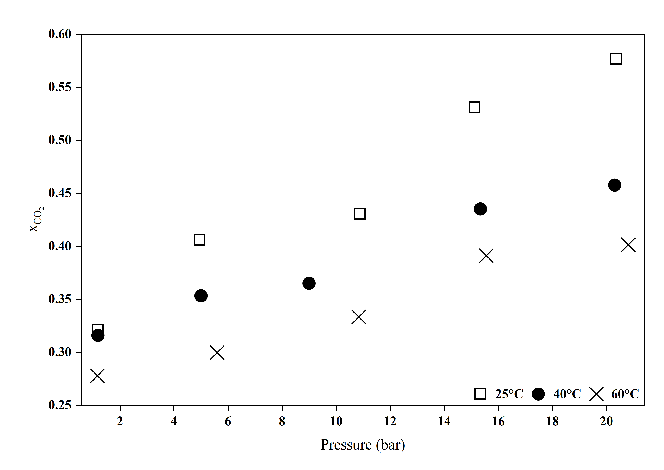 | 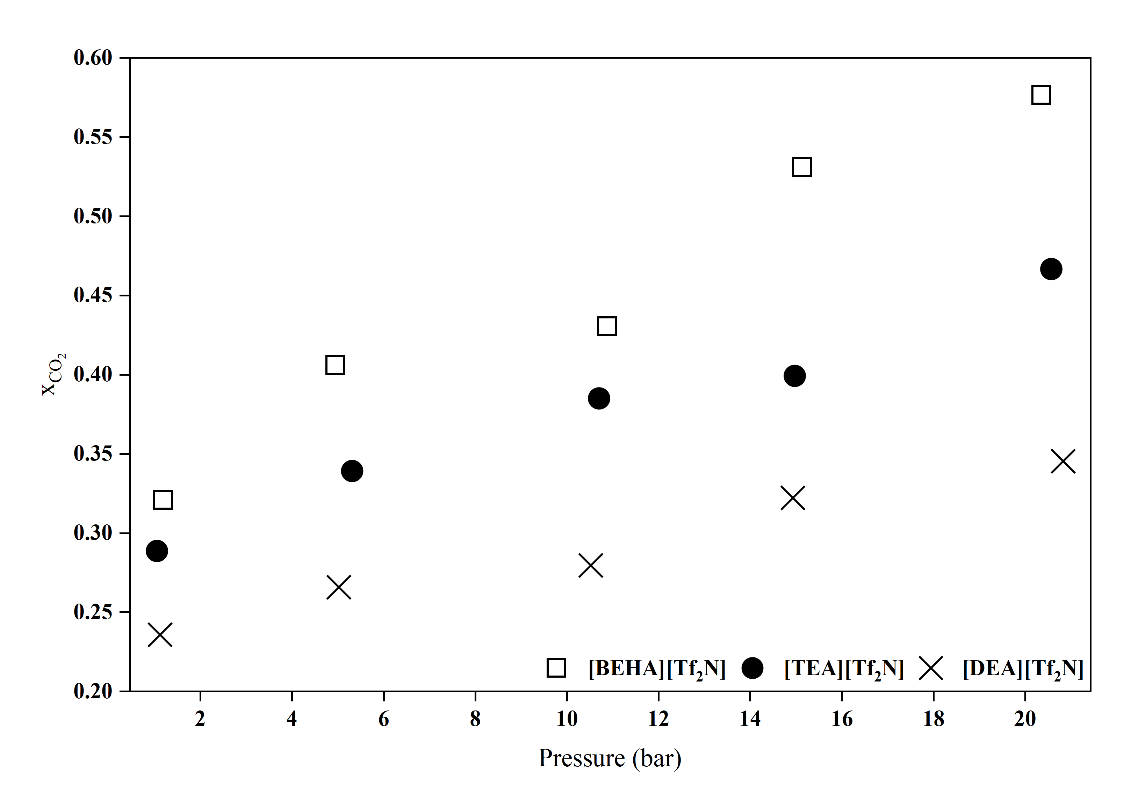
(a) | (b)
3.5 Recyclability Performance of [BEHA][Tf₂N]
The recyclability of [BEHA][Tf₂N] was evaluated to assess its stability and reusability for CO₂ capture. As shown in Figure X, only minimal variations in CO₂ uptake were observed between two consecutive absorption–desorption cycles at 298.15, 313.15, and 333.15K, demonstrating consistent performance. FTIR and ¹H NMR analyses after desorption Figure X revealed no detectable changes in spectral features compared to the fresh sample, confirming that the molecular structure of [BEHA][Tf₂N] remained intact. These results indicate that [BEHA][Tf₂N] exhibits excellent thermal and chemical stability, making it suitable for repeated CO₂ capture applications.
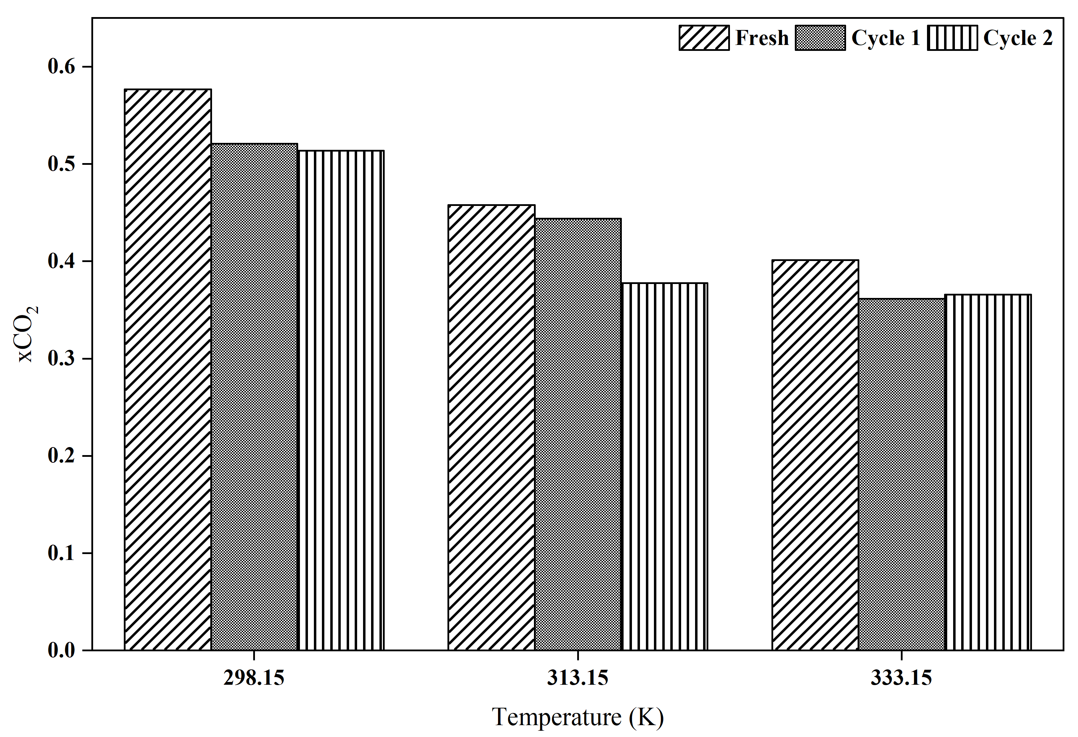 | 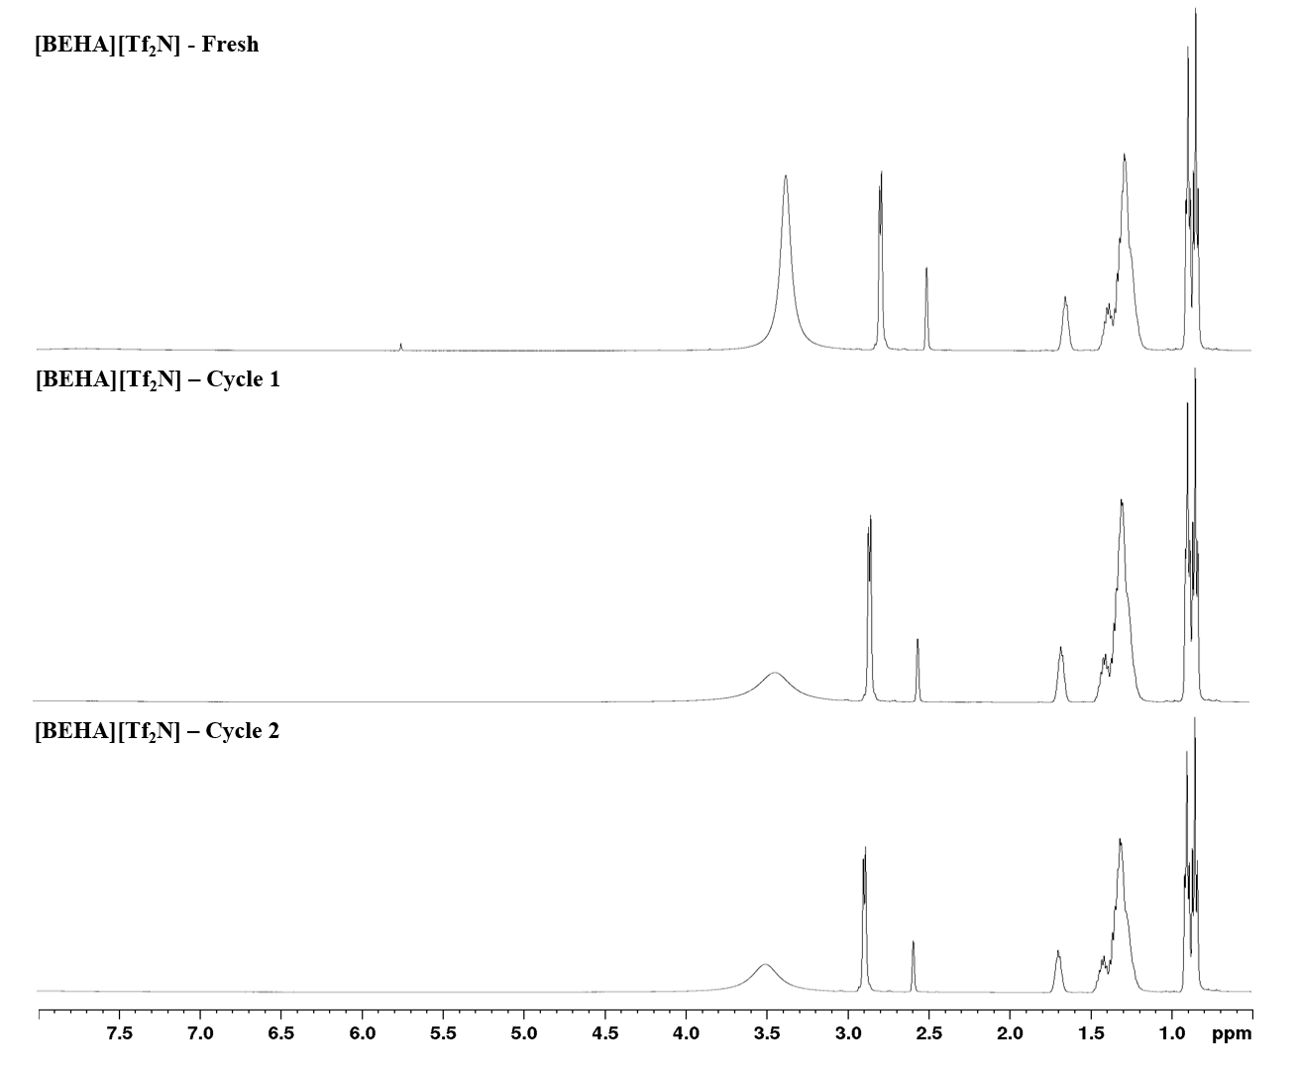
(a) | (b)

Conclusion
In conclusion, three HPILs were successfully synthesized, characterized, and evaluated for their CO₂ absorption performance at different temperatures which are 298.15, 313.15, and 333.15K and pressures up to 20 bar. The CO₂ solubility in all studied ionic liquids increased with pressure, while a negative correlation with temperature was observed. The alkyl chain length of the cation showed a pronounced effect on CO₂ absorption capacity, attributed to the increase in free volume (V_{f}). In addition, recyclability tests conducted for [BEHA][Tf₂N] at all temperatures over two consecutive cycles revealed consistent CO₂ uptake and excellent structural stability, indicating that this ionic liquid is a promising alternative to conventional amine-based solvents such as MEA for CO₂ capture applications.
Acknowledgment: The authors would like to acknowledge the Yayasan Universiti Teknologi PETRONAS (YUTP), for providing financial assistance under YUTP-FRG (015LC0-436), Universiti Teknologi PETRONAS and Centre for Research in Ionic Liquid (CORIL) for providing required assistance in completing the work.
References

